S3 bucket defined in aws

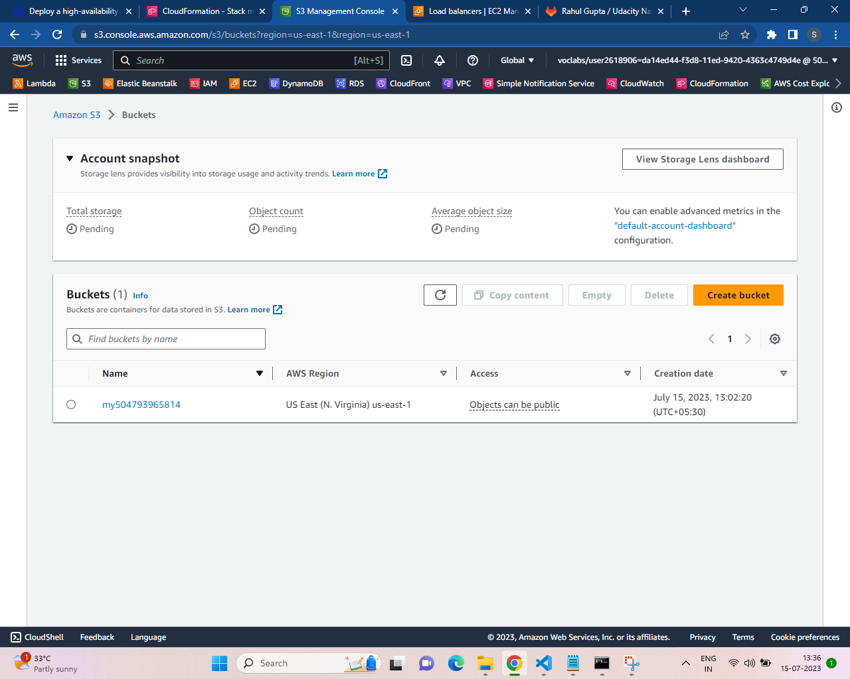

‘MyUdagram.zip’ file available in the S3 bucket

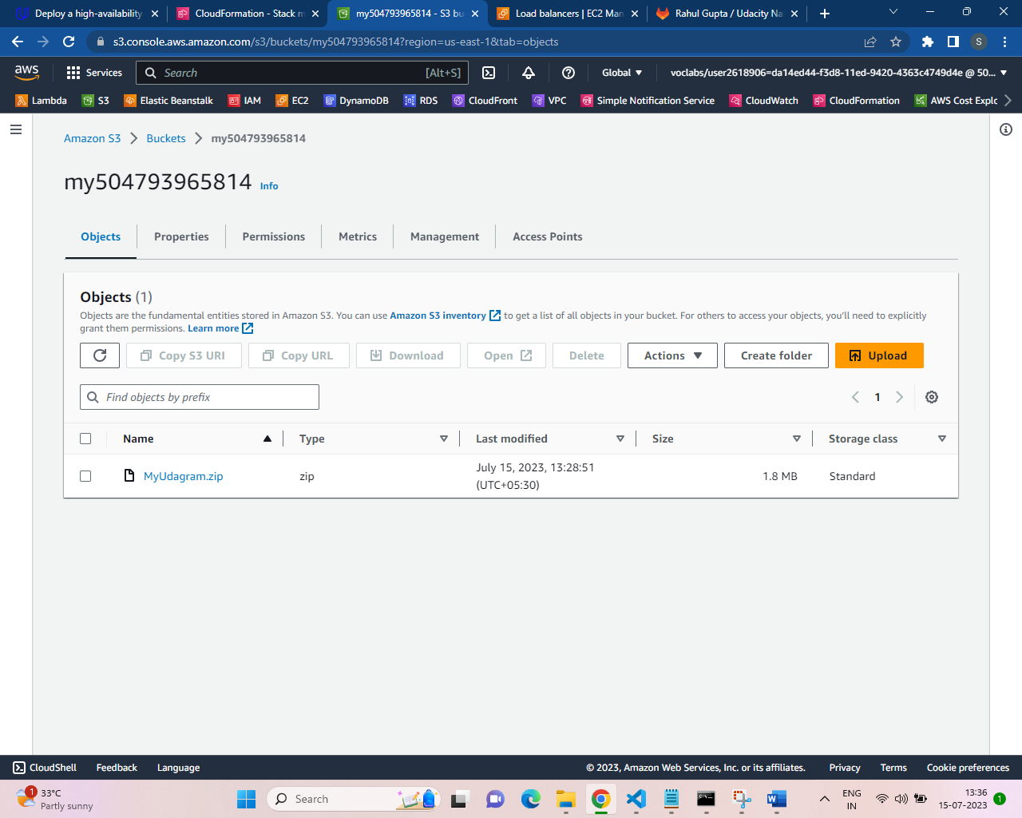

Command executed to create ‘myUdagramWebapp-network’ @ 13:36 15-07-2023

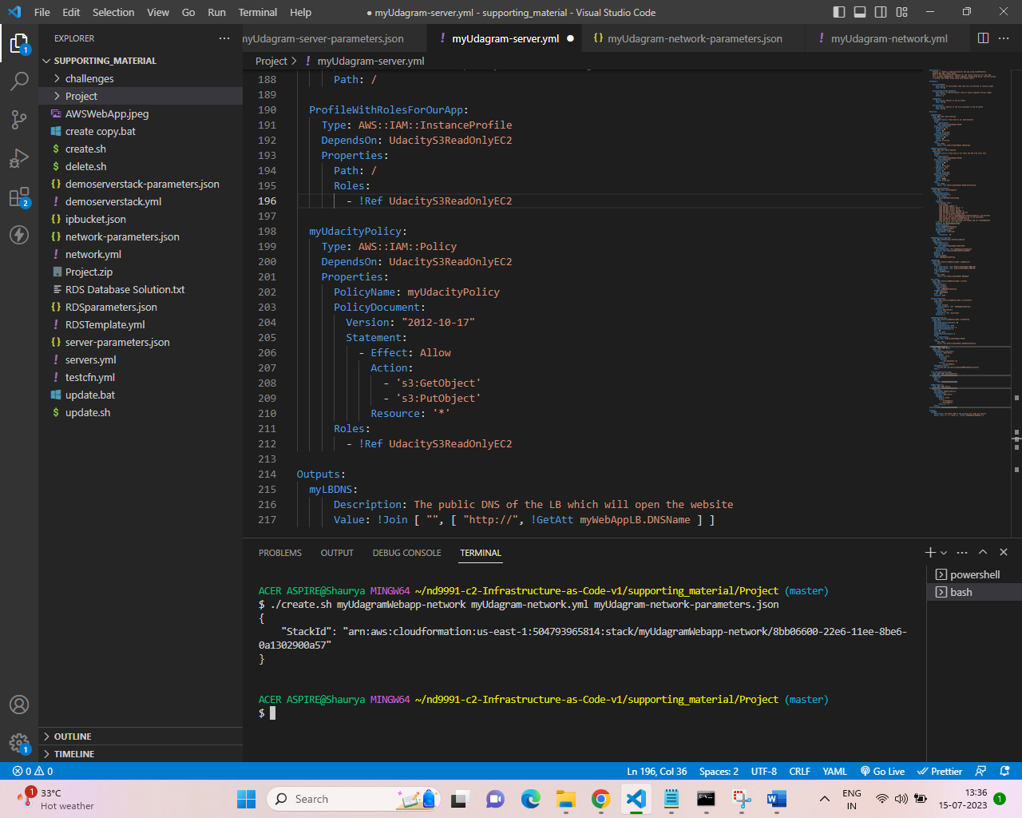

Cloud formation stack ‘myUdagramWebapp-network’ create time in sync with above details

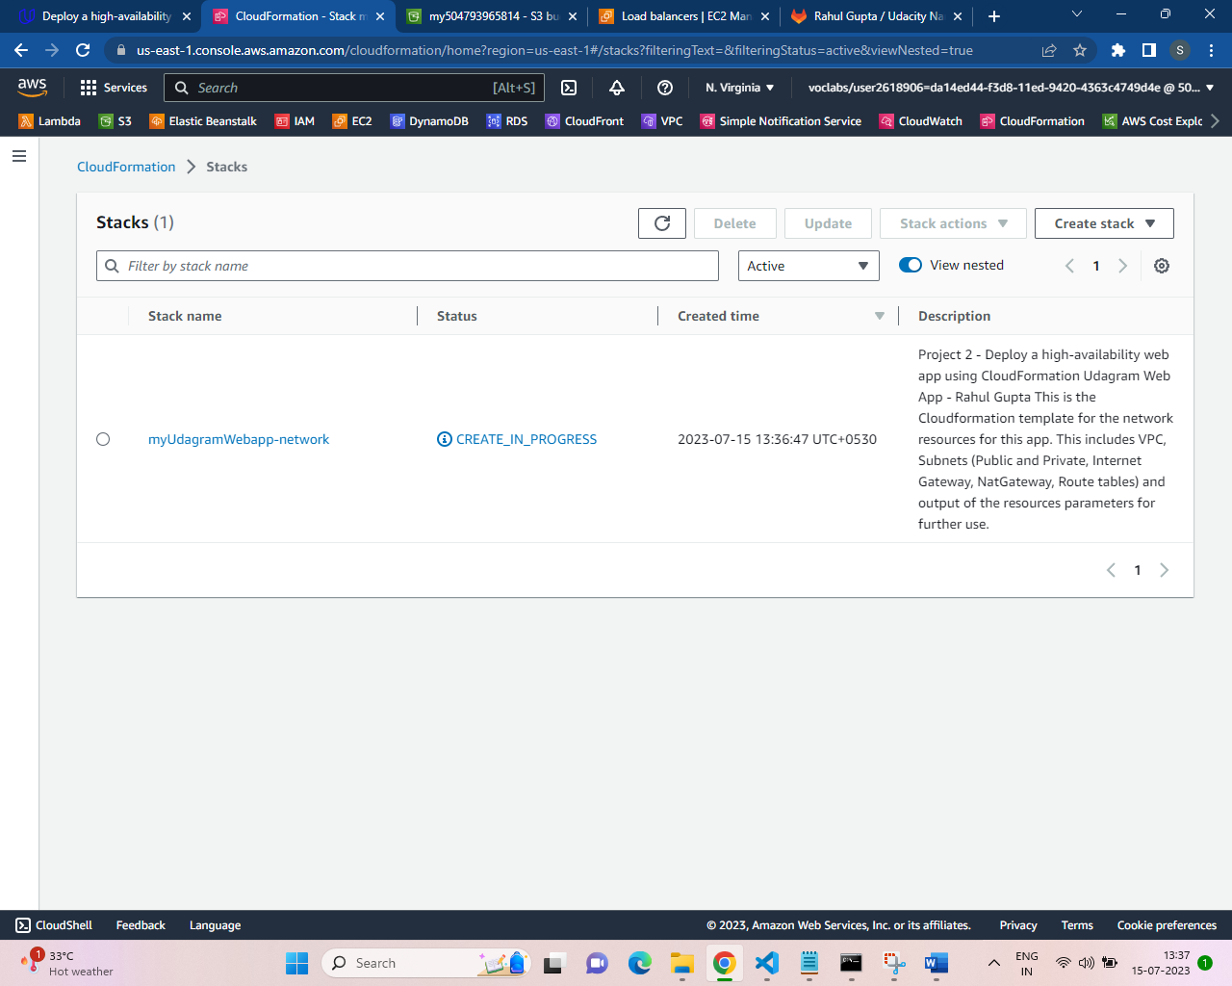

Cloud formation stack ‘myUdagramWebapp-network’ create completed successfully

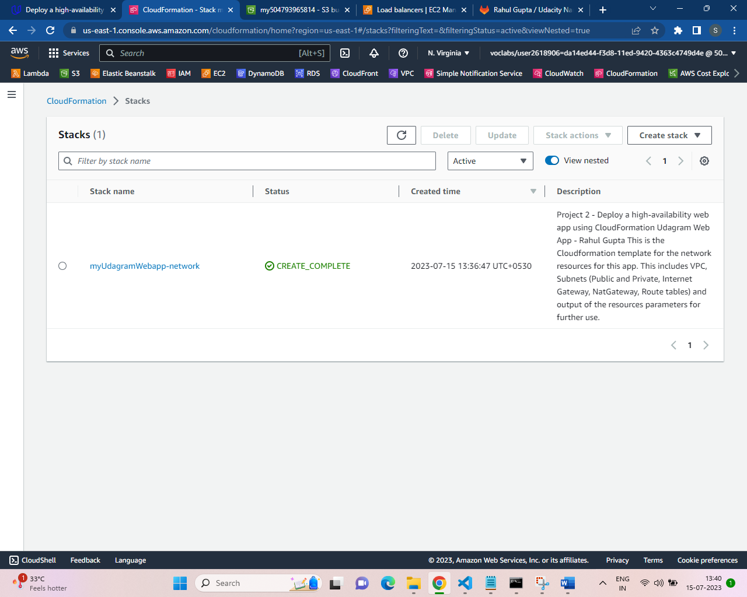

Stack ‘myUdagramWebapp-network’ Output screenshot 1

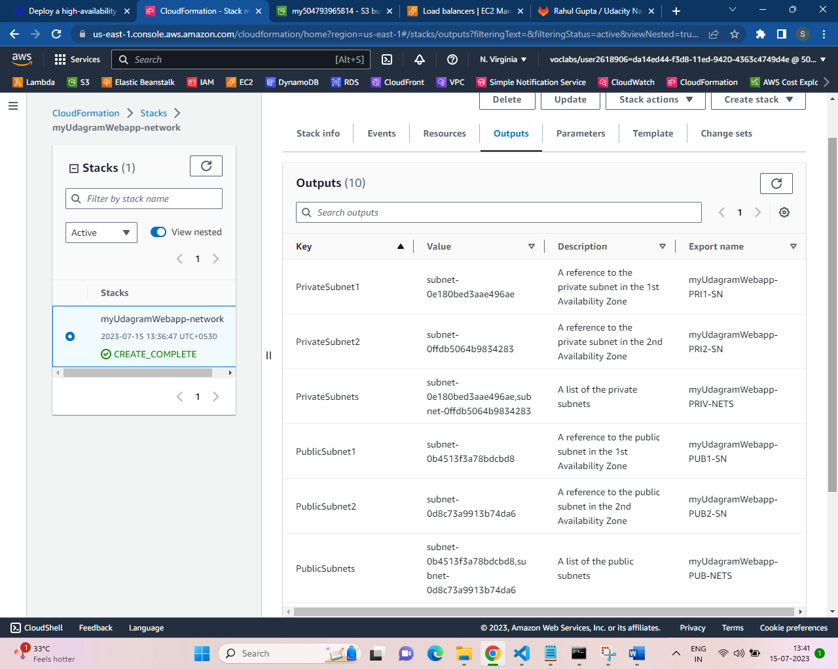

Stack ‘myUdagramWebapp-network’ Output screenshot 2

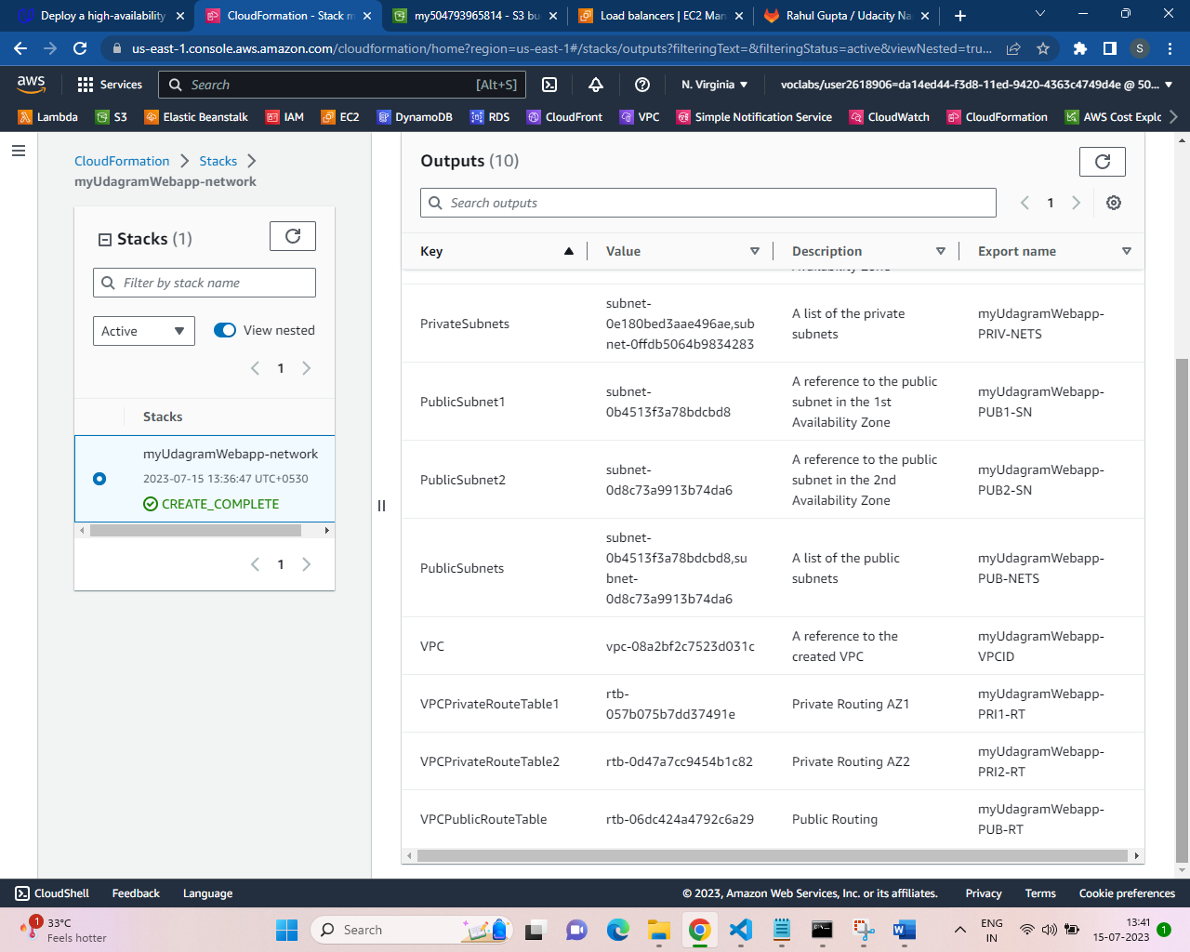

Stack ‘myUdagramWebapp-network’ Parameter Screenshot

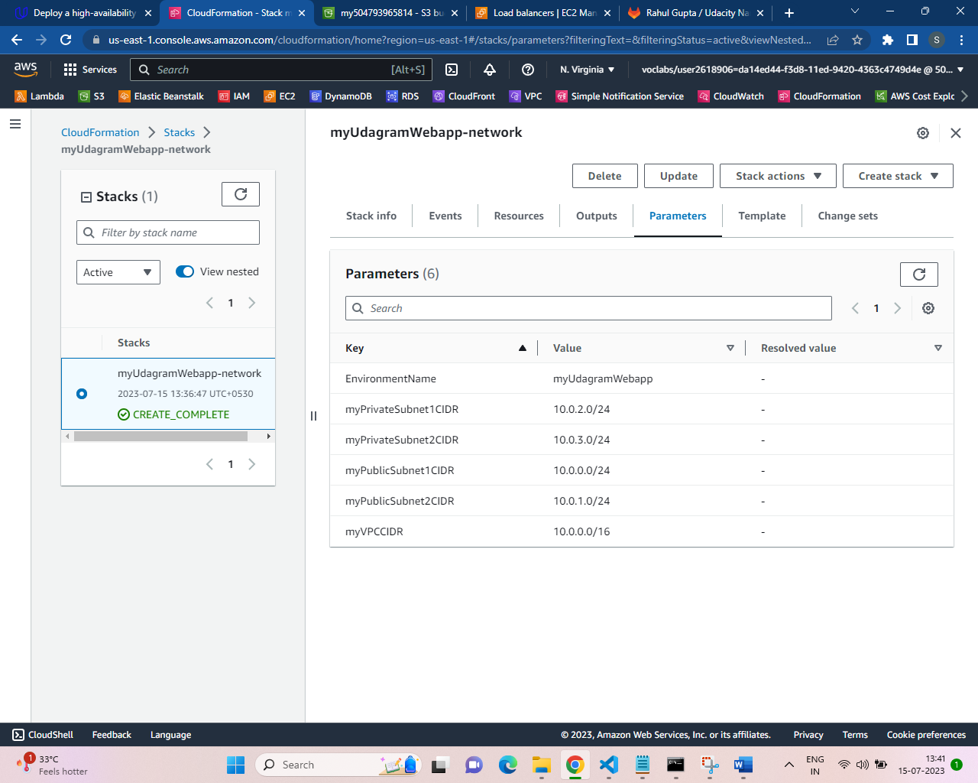

Command executed to create ‘myUdagramWebapp-server’ @ 13:42 15-07-2023

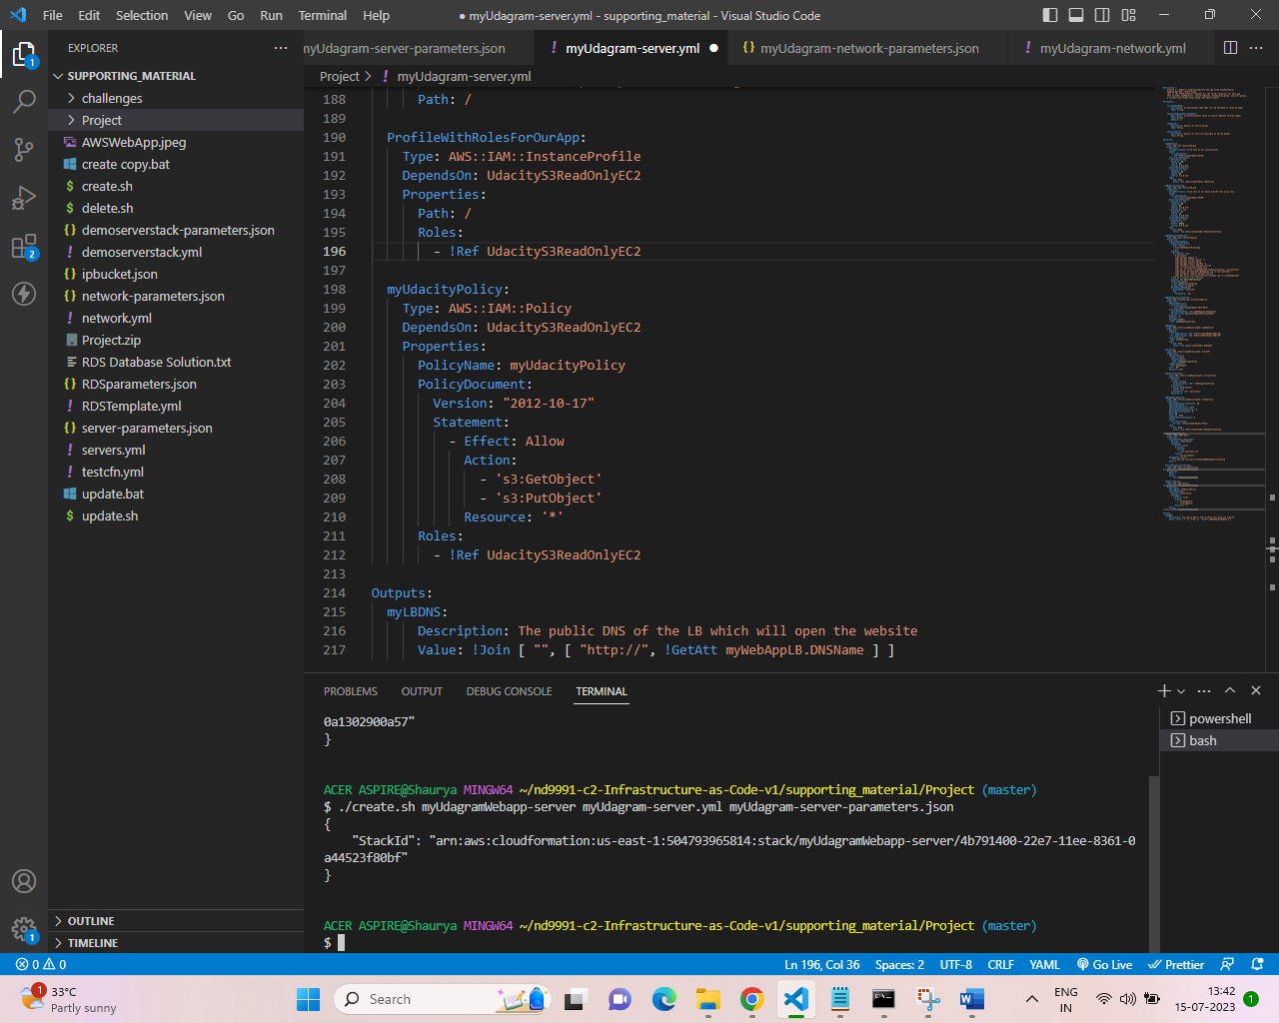

Cloud formation stack ‘myUdagramWebapp-server’ create time in sync with above details

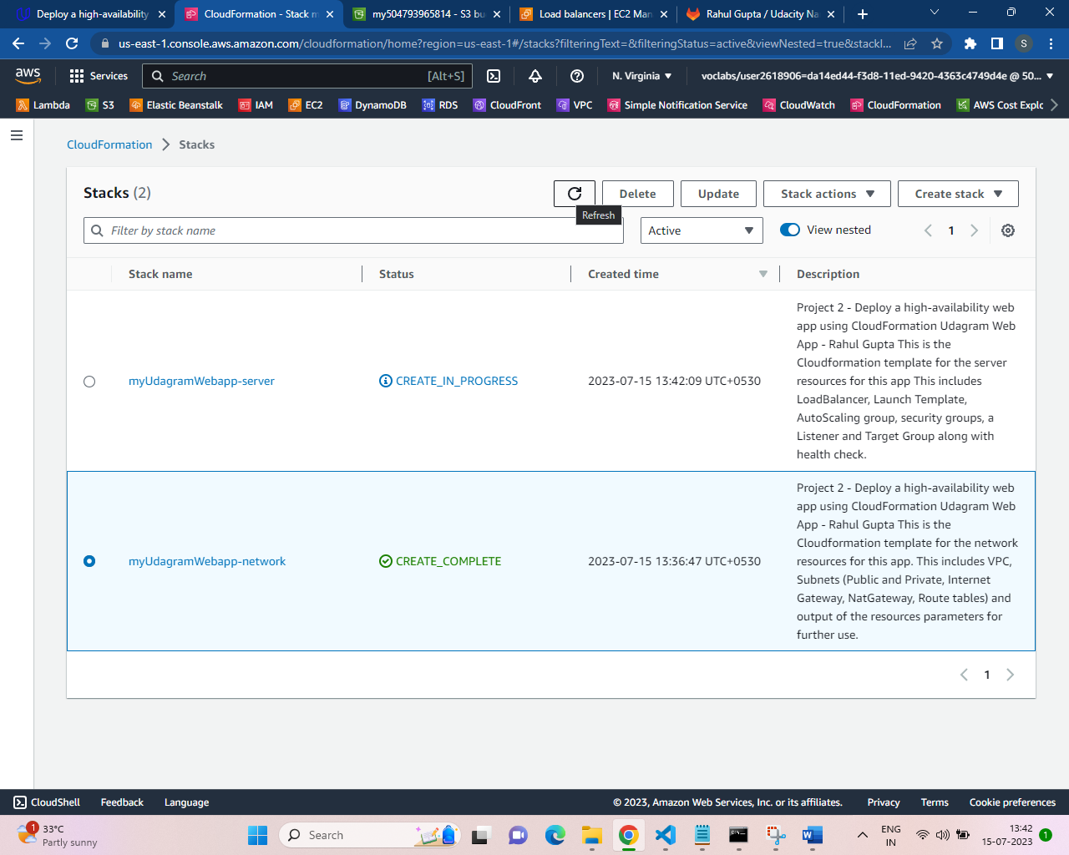

Cloud formation stack ‘myUdagramWebapp-server’ create completed successfully

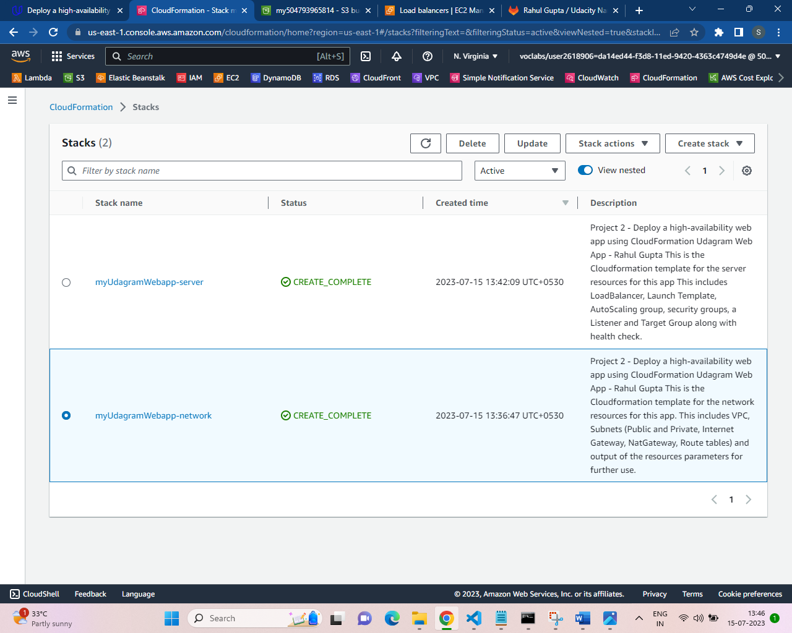

Stack ‘myUdagramWebapp-server’ Output screenshot

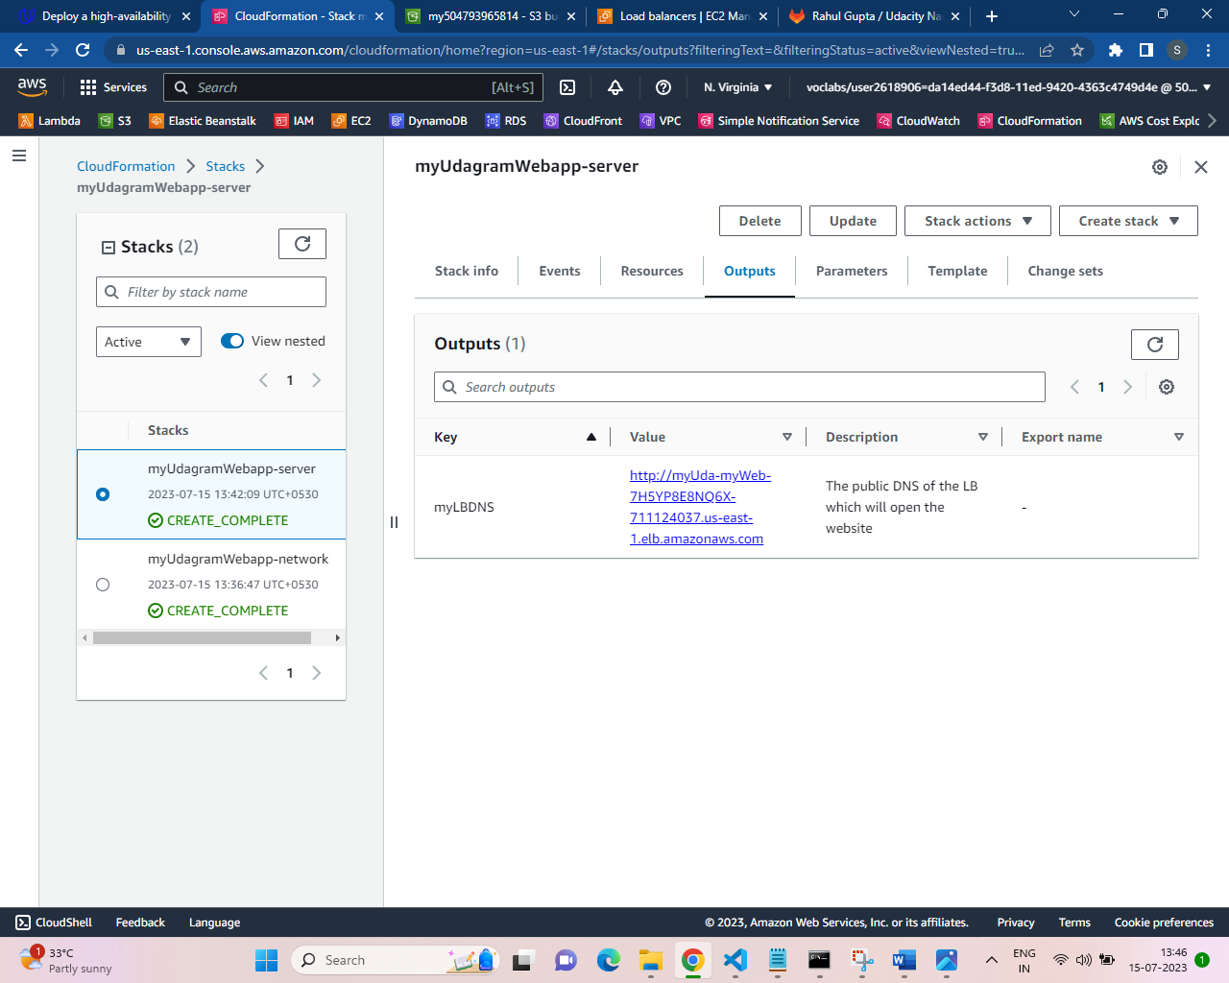

Stack ‘myUdagramWebapp-server’ Parameters screenshot

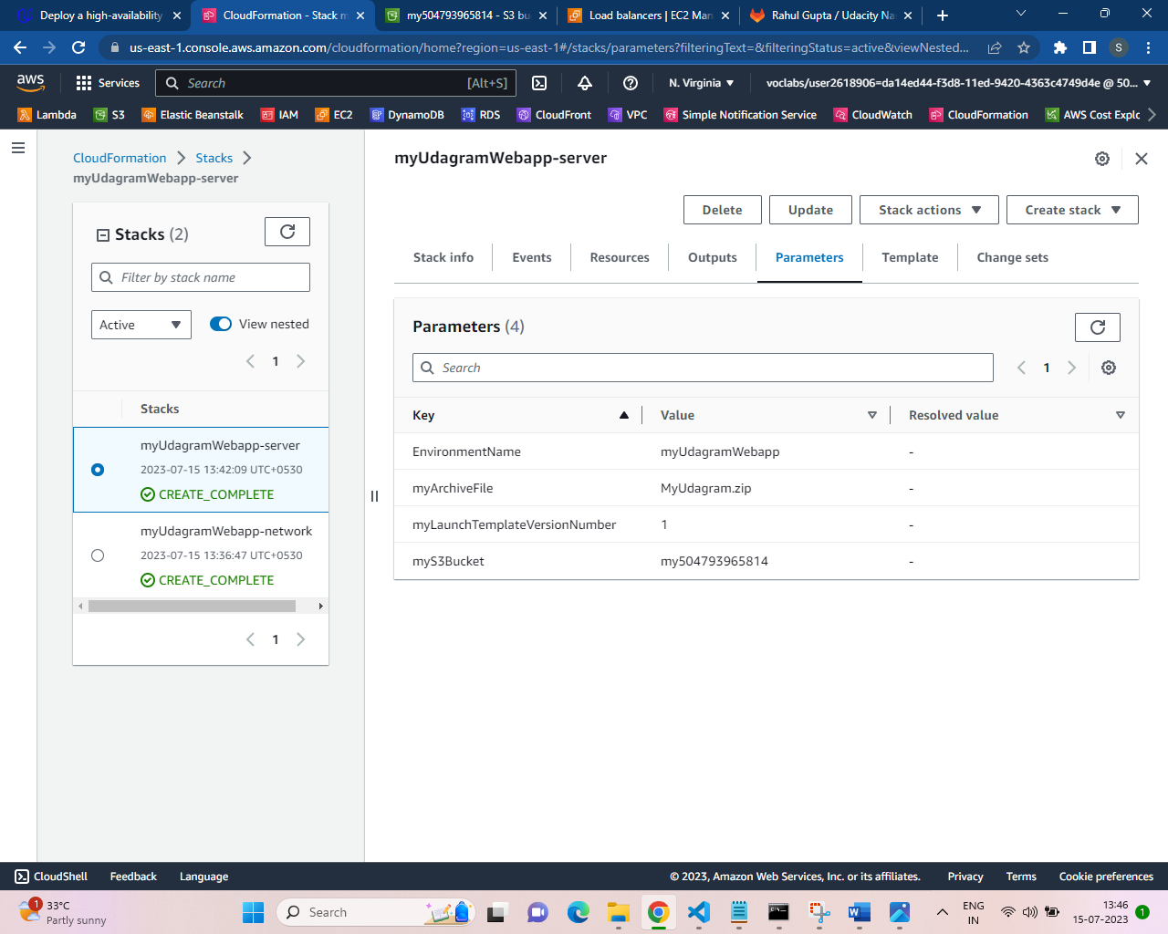

Load balancer details (along with DNS name)

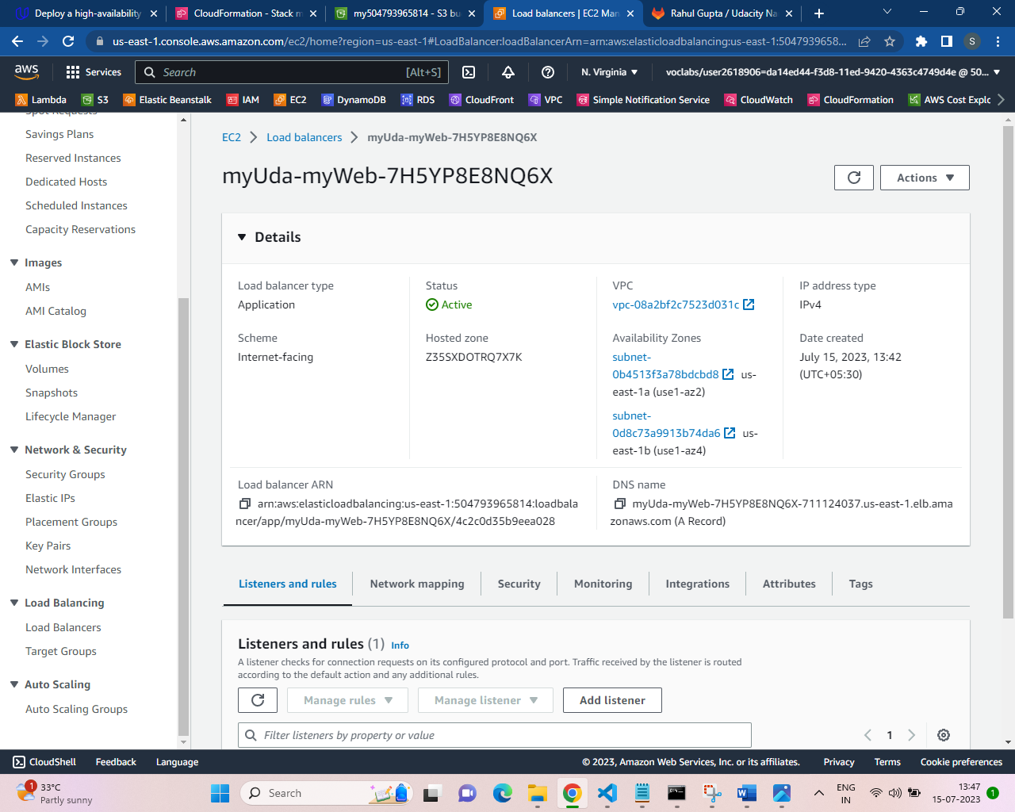

Target Group Details (with health check)

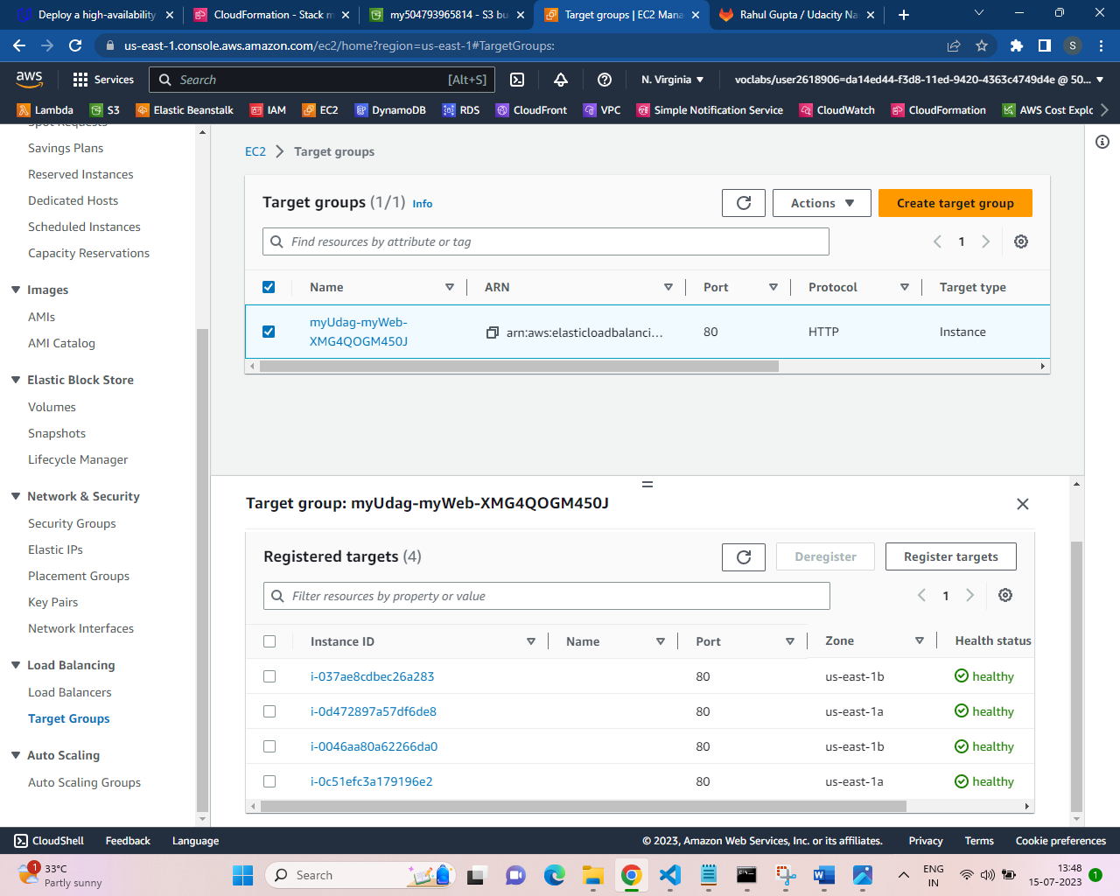

Aitu Scaling Group Details (with capacity)

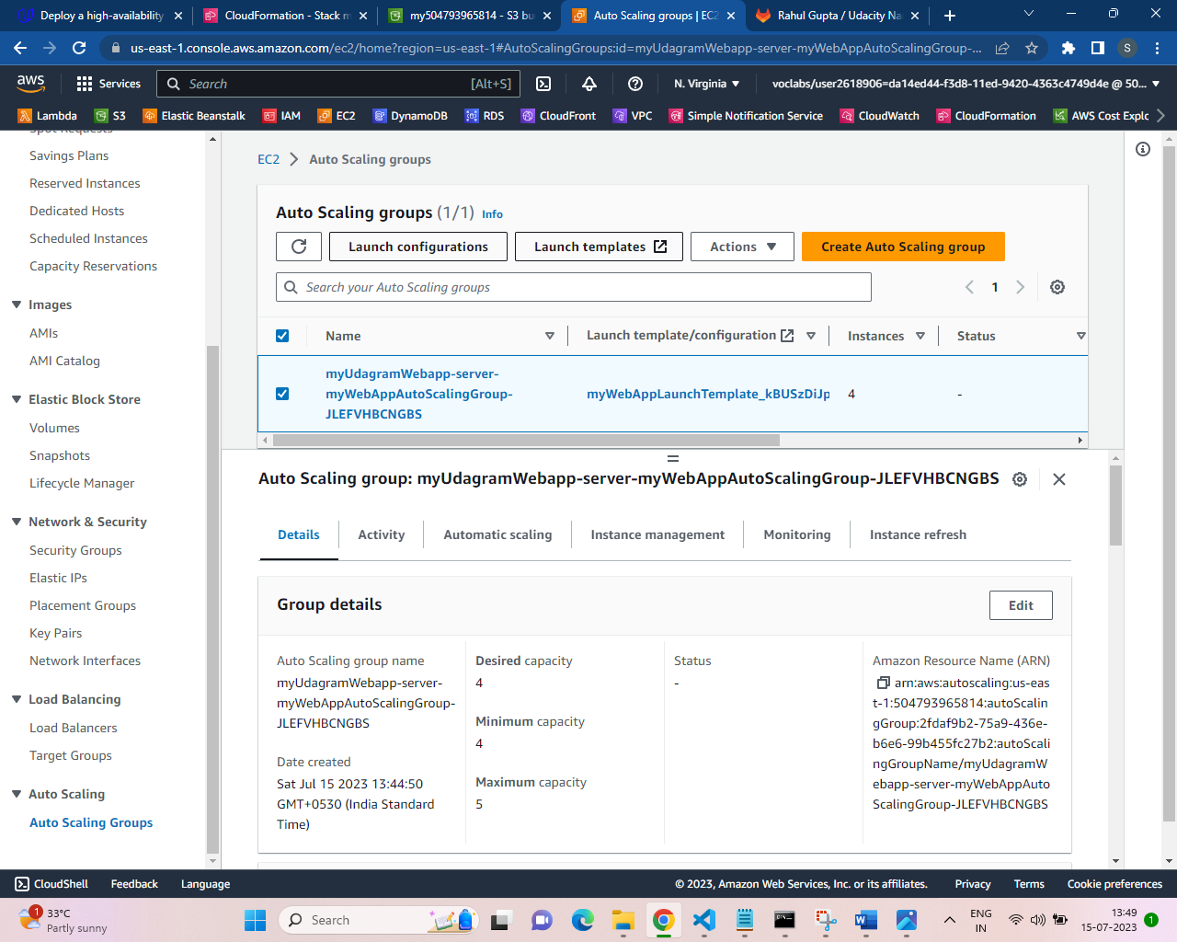

Ec2 Instances (with status check completed)

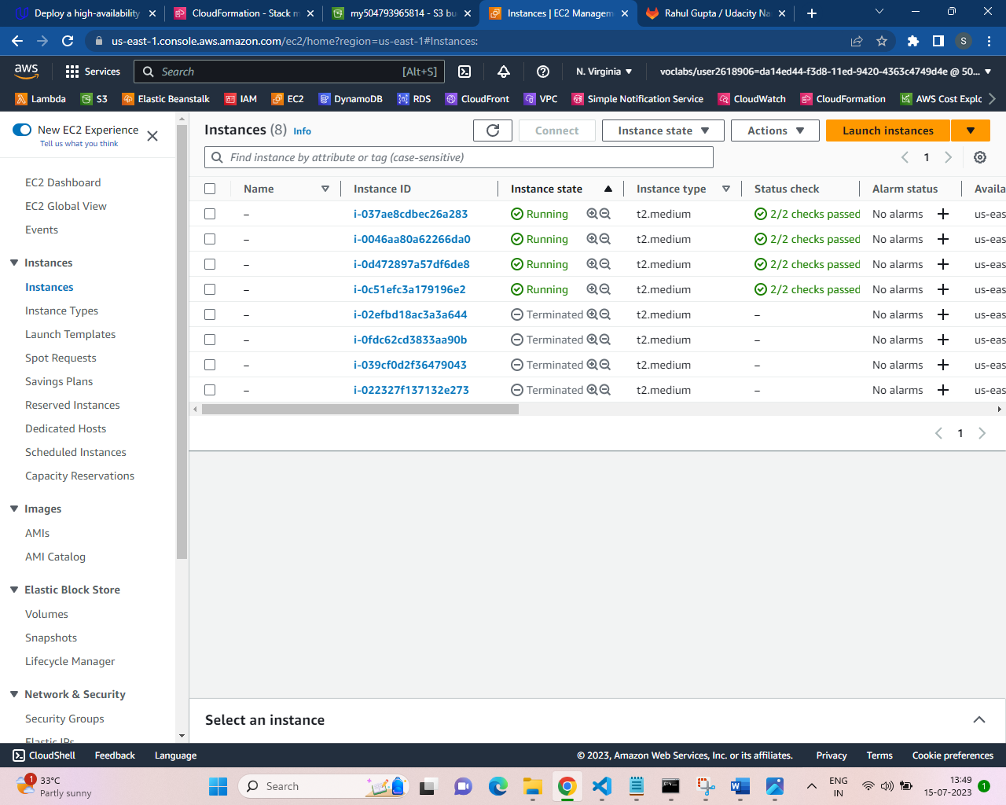

Web App URL works fine (using the URL from Cloudformation server stack output)

